Chapter 11 practice problems
1.
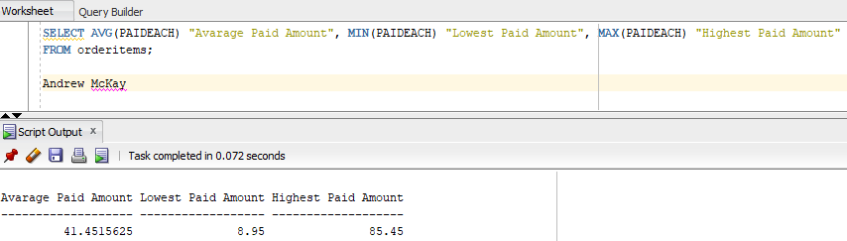
2.
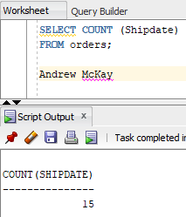
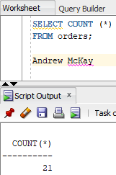

3.
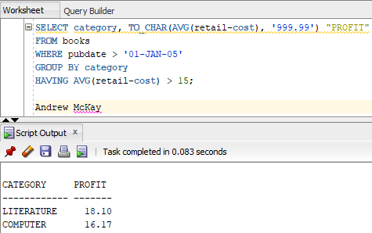

This Query Pulls the Category and the Average profit of Items from the books table where the publishing date is later then Jan 1st 2005 by category having a greater average profit then $15

4.
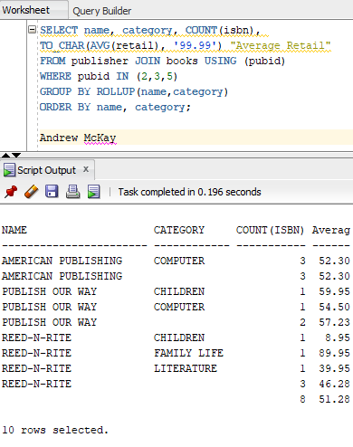
This selects the name category, number of ISBNs and the Average retail price of the books from the books table joined with the publisher table using publisher id where publisher includes 2,3 or 5. It’s grouped by rollup which means it combines the name and category columns, takes the subtotals of the two and then returns a final total. The list is ordered first by name then category.

5.
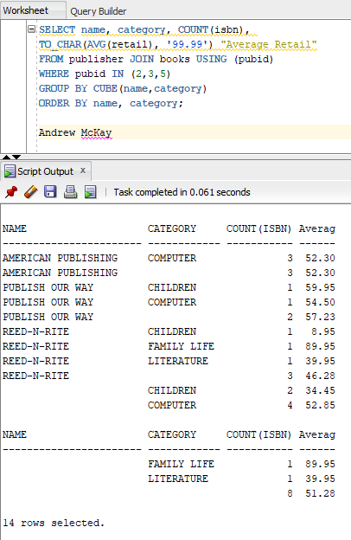
This statement pulls the name, category and count of ISBNs from the books table joined with the publisher table using the publisher id, only where the publisher ID includes a 2,3, or 5, it’s grouped by name and category with cube, showing all possible combinations and ordered by name followed by category.

